EXPERIMENT 12
Port Scanning Tools
AIM : To identify open ports and running services on a target system using port scanning tools like Nmap for security analysis.
DESCRIPTIONS
1. nmap -sT 192.0.2.10 (TCP Connect Scan)
The nmap -sT 192.0.2.10 command performs a TCP Connect Scan to identify open ports on the target system by completing the TCP three-way handshake.
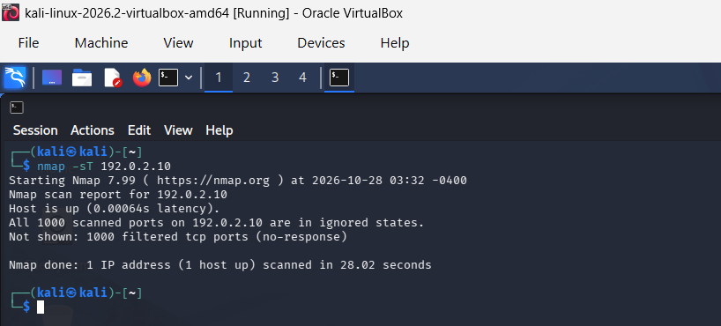
2. nmap -sS 192.0.2.10 (TCP SYN Scan)
The nmap -sS 192.0.2.10 command performs a TCP SYN Scan to identify open ports by sending SYN packets without completing the full TCP three-way handshake.
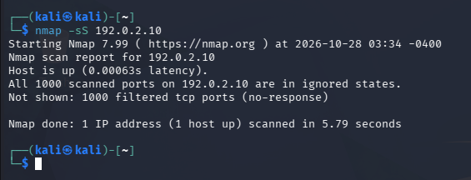

3. nmap -sU 192.0.2.10(UDP Scan)
The nmap -sU 192.0.2.10 command performs a UDP scan to identify open UDP ports and detect services running on the target system.
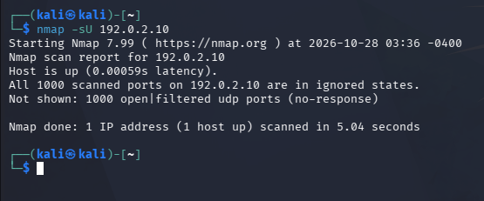
4. nmap -sA 192.0.2.10 (ACK Scan)
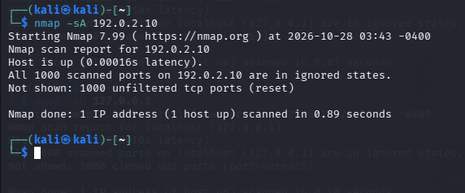

Scanning Techniques
Flag | Use | Example
-sT | TCP connect port scan | nmap -sT 192.168.1.1
-sS | TCP syn port scan | nmap -sS 192.168.1.1
–sU | UDP port scan | nmap –sU 192.168.1.1
–sA | TCP ack port scan | nmap –sA 192.168.1.1

RESULT : The ACK scan helps identify filtered and unfiltered ports on the target system and assess firewall filtering behavior.

